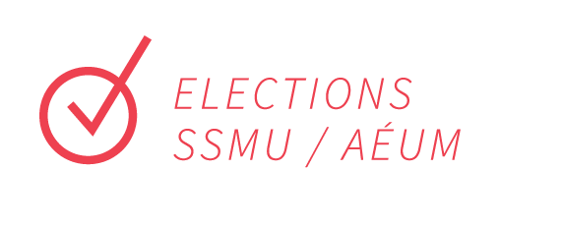

Dear Applicant,

Thank you for submitting this kit to Elections SSMU! Please make sure to read all the information in this package and fill out all the necessary forms.

Should you wish to virtually meet to discuss your campaign, please feel free to book an appointment via email through elections@ssmu.ca.

You can ask us any questions you may have about the election process or just chat with us if you’re unsure about running your campaign. If you have any comments or queries, please don’t hesitate to contact us via email at elections@ssmu.ca or deo@ssmu.ca.

Thank you and good luck!

Noème Fages
Chief Electoral Officer
elections@ssmu.ca

Jonathan Dong
Deputy Electoral Officer
deo@ssmu.ca

INSTRUCTIONS

- Submit this completed kit by email any time before 5:00PM on November 7th, 2022. Please submit each page of the nomination kit as 1 attachment to elections@ssmu.ca

Late forms will be rejected without appeal, and physical packages will not be accepted.

- We’ll send you a confirmation email once we’ve received your kit. If you do not receive a confirmation email within a reasonable amount of time, your packet may not have been received. If this should occur, please email elections@ssmu.ca. You might want to keep a copy of this kit for your personal records before handing it in.

- Collect signatures from at least 25 members of the SSMU who wish to support placing your campaign, by asking them to fill out a Google Form which will be provided by Elections SSMU after submitting this form and gaining approval for this campaign. We are very strict about this, and will remove entries with incomplete information. (*Note: you might want to include extra signatures to ensure all of the required ones are valid). You cannot begin campaigning until the collection of these signatures has been confirmed with Elections SSMU.

- Elections SSMU requires that the conduct of all candidates respect the Constitution and By-laws of the SSMU. The officers of Elections SSMU are specially charged to maintain good electoral decorum and enforce campaign violation regulations. Please read the electoral by-laws and relevant constitution articles which can be found at:
http://ssmu.ca/governance/constitution-internal-regulations-policies/

- Attend the mandatory “No” Campaign Committee Chairs’ meeting, November 7th at 5:30 PM. At this meeting, you will get a chance to meet the Elections SSMU Officers and fellow Committee Chairs, and find out how the election works. More importantly, we will explain the Elections By-Laws, as well as the rules, procedures and possible sanctions that are applicable. Please contact Elections SSMU as soon as possible if you cannot make it to this meeting.

- Campaign exclusively during the Campaign Period: November 8th at 9:00 AM - November 18th at 5:00 PM EST

- Pensketches for NO Campaign Committees are limited to 150 words in English and 200 words in French. Due on November7th, at Midnight (EST).

Recap of Important Dates:

- Meeting for “No” Campaign Committee Chairs
November 7th, 5:30 PM (Zoom)

- YES/NO Pensketches Due
November 7th, 2022, at Midnight (EST)

- Campaign Period
November 8th at 9:00 AM - November 18th at 5:00 PM EST

* Please be aware that campaigning can only be done during the campaign period. Violation of this rule will result in disqualification.

- Polling Period
November 14th at 9:00 AM - November 18th at 5:00 PM EST

- Announcement of results (via Elections SSMU website and Facebook)
As soon as results are verified on November 18th.

Nominated Question in Opposition to
Please include the name of the question your campaign will be in opposition to. Nominated questions can be found here

_____________________________________________________________________________________

_____________________________________________________________________________________

Personal Information

Name: _____________________________________________

Faculty and Year: _____________________________________ Student ID #: _________________

Address: ____________________________________________________________________________

Phone #: (______) ______ - _____________ Email: _____________________________________

I have read and completed all of the steps provided in the instructions of this kit, and agree to be the campaign chair for this question, unless otherwise indicated to Elections SSMU:

______________________________________________________________________________

Signature Date

