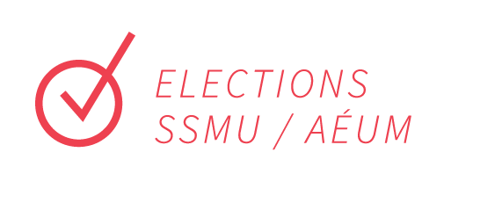

Dear Applicant,

Thank you for submitting your question to the SSMU Winter Referendum! Please make sure to read all the information in this package and fill out all the necessary forms.

Should you wish to virtually meet with a person to discuss your campaign, please feel free to book an appointment via email through elections@ssmu.ca.

You can ask us any questions you may have about the election process or just chat with us if you’re unsure about running your question. If you have any comments or queries, please don’t hesitate to contact us via email at elections@ssmu.ca or deo@ssmu.ca.

Thank you and good luck!

Noème Fages
Chief Electoral Officer
elections@ssmu.ca

Alejandro Gonzalez Calle
Deputy Electoral Officer
deo@ssmu.ca

INSTRUCTIONS
- Compose your referendum question and obtain permission from Elections SSMU to run it. When composing your question, make sure it aligns with the SSMU governance documents.

- Submit this completed kit by email any time before October 30th, 2023 at 5:00PM. Please submit each page of the nomination kit as 1 attachment to elections@ssmu.ca, as well as your referendum question.

Late forms will be rejected without appeal, and physical packages will not be accepted.

- We’ll send you a confirmation email once we’ve received your kit. If you do not receive a confirmation email within a reasonable amount of time, your packet may not have been received. If this should occur, please email elections@ssmu.ca. You might want to keep a copy of this kit for your personal records before handing it in.

- Collect signatures from at least 100 members of the SSMU who wish to support placing your referendum question on the ballot, by asking them to fill out a Google Form which will be provided by Elections SSMU after gaining approval for your question and submitting this form. No more than 30% of the signatures may be from students from the same faculty. We are very strict about this, and will remove entries with incomplete information. (*Note: you might want to include extra signatures to ensure all of the required ones are valid)

- Elections SSMU requires that the conduct of all candidates respect the Constitution and By-laws of the SSMU. The officers of Elections SSMU are specially charged to maintain good electoral decorum and enforce campaign violation regulations. Please read the electoral by-laws and relevant constitution articles which can be found at:
http://ssmu.ca/governance/constitution-internal-regulations-policies/

- Attend the mandatory in person (which will also be held online at the same time for those who prefer) Committee Chairs’ meeting on November 13th at 5:30 PM EST. At this meeting, you will get a chance to meet the Elections SSMU Officers and fellow Committee Chairs, and find out how the election works. More importantly, we will explain the Elections By-Laws, as well as the rules, procedures and possible sanctions that are applicable. Please contact Elections SSMU as soon as possible if you cannot make it to this meeting.

- Campaign exclusively during the Campaign Period: November 14th at 9:00 AM - November 24th at 5:00 PM EST

- Pensketches for YES/NO Campaign Committees are limited to 150 words in English and 200 words in French. Due on November 7th, at Midnight (EST).

Recap of Important Dates to Remember:
- Nomination Period for Student Initiated Questions
October 9th at 9:00 AM - October 30th at 5:00 PM
- Meeting for Committee Chairs
November 13th at 5:30 PM EST (hybrid: both in person and online)

- YES/NO Pensketches Due
November 7th, at Midnight (EST)

- Campaign Period
November 14th at 9:00 AM - November 24th at 5:00 PM EST

* Please be aware that campaigning can only be done during the campaign period. Violation of this rule will result in disqualification.

- Polling Period
November 14th at 9:00 AM - November 24th at 5:00 PM EST

- Announcement of results (via Elections SSMU website and Facebook)
As soon as results are verified on November 24th.

Nominated Question
_________________________________________________________________________________________________________________________________________________________________________________________________________________________________________________________________________________________________________________________________________________________________________________________________________________________________________
_____________________________________________________________________________________
_____________________________________________________________________________________

Personal Information

Name: _____________________________________________

Faculty and Year: _____________________________________ Student ID #: _________________

Address: ____________________________________________________________________________

Phone #: (______) ______ - _____________ Email: _____________________________________

I have read and completed all of the steps provided in the instructions of this kit, and agree to be the campaign chair for this question, unless otherwise indicated to Elections SSMU:

______________________________________________________________________________

Signature Date

